|  |
| --- |
|  |
| The Specification |
| [Type the document subtitle] |
|  |
| **[Your Name]** |
| **[Pick the date]** |

[Type the abstract of the document here. The abstract is typically a short summary of the contents of the document. Type the abstract of the document here. The abstract is typically a short summary of the contents of the document.]

Table of Contents

[To update the table of contents, right click the message below and select Update Field (F9 on PC, ⌥⌘U on Mac).]

**No table of contents entries found.**

1. Pages
   1. Page Tree

Home  
 Booking  
 Extras  
 Personal Information  
 Respons page  
 Vehicle  
 Type A  
 Type B  
 Type C  
 Type D  
 Contact

* 1. Home
     1. User Interface

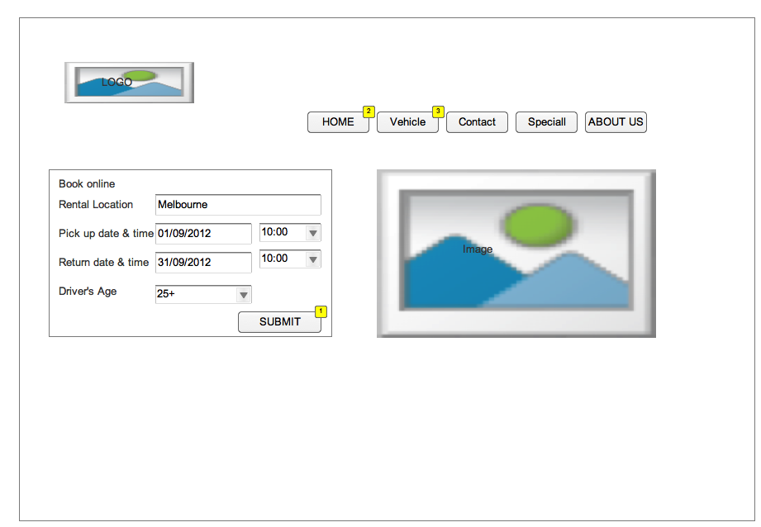

* + 1. Widget Table

| Footnote | Interactions |
| --- | --- |
| 1 | OnClick:  Case 1:  Open Booking in Current Window |
| 2 | OnClick:  Case 1:  Open Home in Current Window |
| 3 | OnClick:  Case 1:  Open Vehicle in Current Window |

* 1. Booking
     1. User Interface

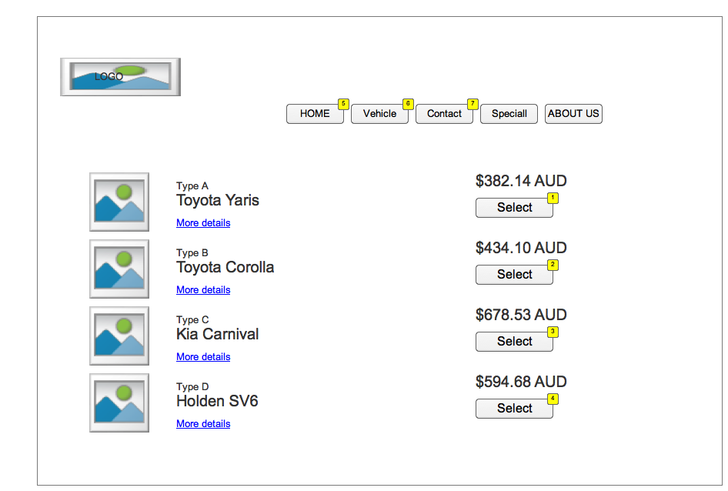

* + 1. Widget Table

| Footnote | Interactions |
| --- | --- |
| 1 | OnClick:  Case 1:  Open Extras in Current Window |
| 2 | OnClick:  Case 1:  Open Extras in Current Window |
| 3 | OnClick:  Case 1:  Open Extras in Current Window |
| 4 | OnClick:  Case 1:  Open Extras in Current Window |
| 5 | OnClick:  Case 1:  Open Home in Current Window |
| 6 | OnClick:  Case 1:  Open Vehicle in Current Window |
| 7 | OnClick:  Case 1:  Open Contact in Current Window |

* 1. Extras
     1. User Interface

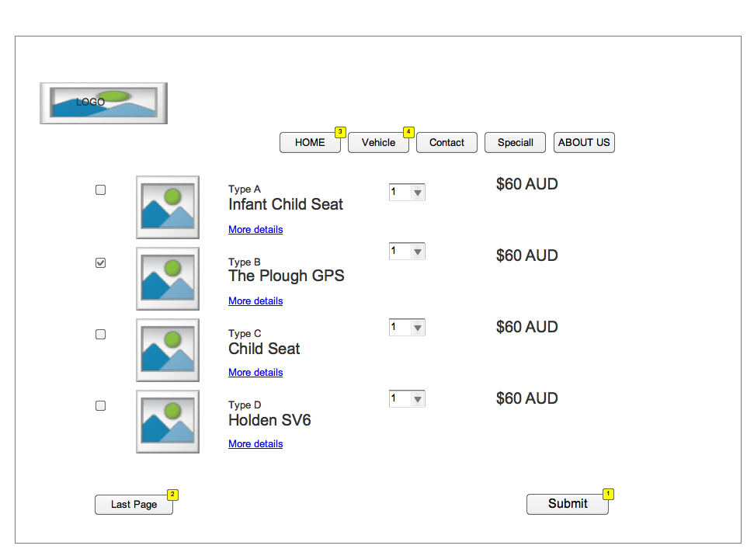

* + 1. Widget Table

| Footnote | Interactions |
| --- | --- |
| 1 | OnClick:  Case 1:  Open Personal Information in Current Window |
| 2 | OnClick:  Case 1:  Open Booking in Current Window |
| 3 | OnClick:  Case 1:  Open Home in Current Window |
| 4 | OnClick:  Case 1:  Open Vehicle in Current Window |

* 1. Personal Information
     1. User Interface

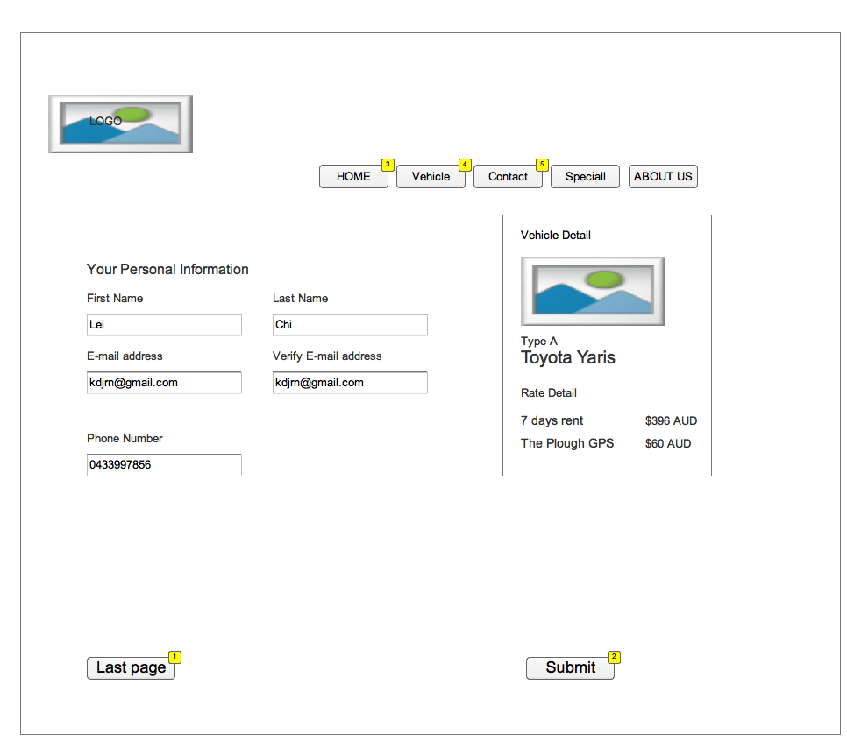

* + 1. Widget Table

| Footnote | Interactions |
| --- | --- |
| 1 | OnClick:  Case 1:  Open Link in Current Window  Open Personal Information in Current Window |
| 2 | OnClick:  Case 1:  Open Respons page in Current Window |
| 3 | OnClick:  Case 1:  Open Home in Current Window |
| 4 | OnClick:  Case 1:  Open Vehicle in Current Window |
| 5 | OnClick:  Case 1:  Open Contact in Current Window |

* 1. Respons page
     1. User Interface

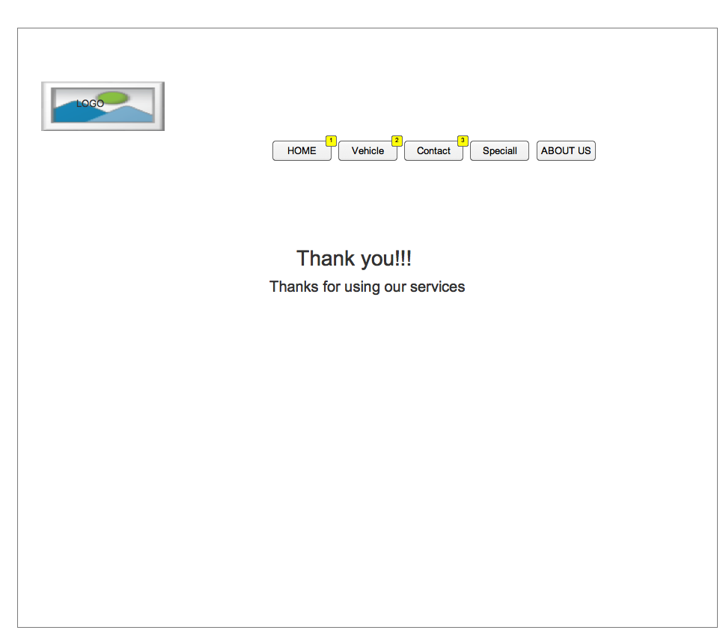

* + 1. Widget Table

| Footnote | Interactions |
| --- | --- |
| 1 | OnClick:  Case 1:  Open Home in Current Window |
| 2 | OnClick:  Case 1:  Open Vehicle in Current Window |
| 3 | OnClick:  Case 1:  Open Contact in Current Window |

* 1. Vehicle
     1. User Interface

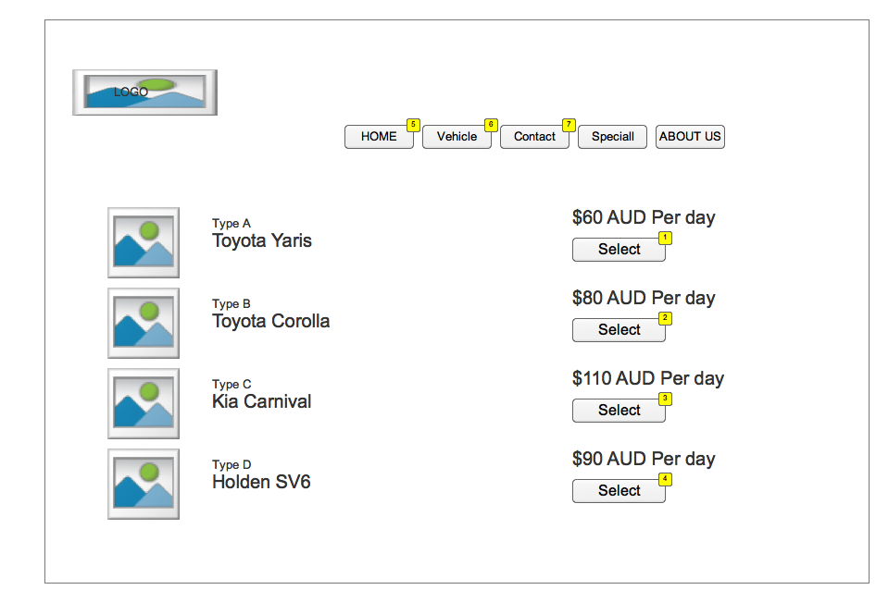

* + 1. Widget Table

| Footnote | Interactions |
| --- | --- |
| 1 | OnClick:  Case 1:  Open Type A in Current Window |
| 2 | OnClick:  Case 1:  Open Extras in Current Window  Open Type B in Current Window |
| 3 | OnClick:  Case 1:  Open Type C in Current Window |
| 4 | OnClick:  Case 1:  Open Type D in Current Window |
| 5 | OnClick:  Case 1:  Open Home in Current Window |
| 6 | OnClick:  Case 1:  Open Vehicle in Current Window |
| 7 | OnClick:  Case 1:  Open Contact in Current Window |

* 1. Type A
     1. User Interface

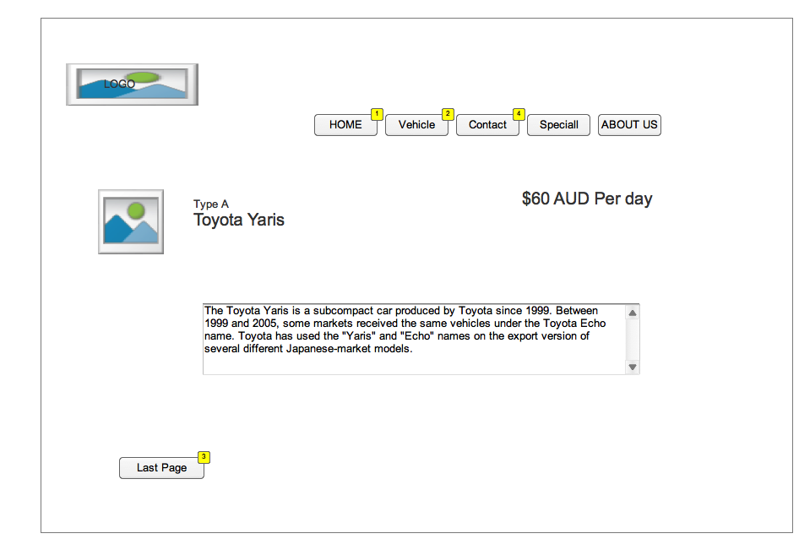

* + 1. Widget Table

| Footnote | Interactions |
| --- | --- |
| 1 | OnClick:  Case 1:  Open Home in Current Window |
| 2 | OnClick:  Case 1:  Open Vehicle in Current Window |
| 3 | OnClick:  Case 1:  Open Vehicle in Current Window |
| 4 | OnClick:  Case 1:  Open Contact in Current Window |

* 1. Type B
     1. User Interface

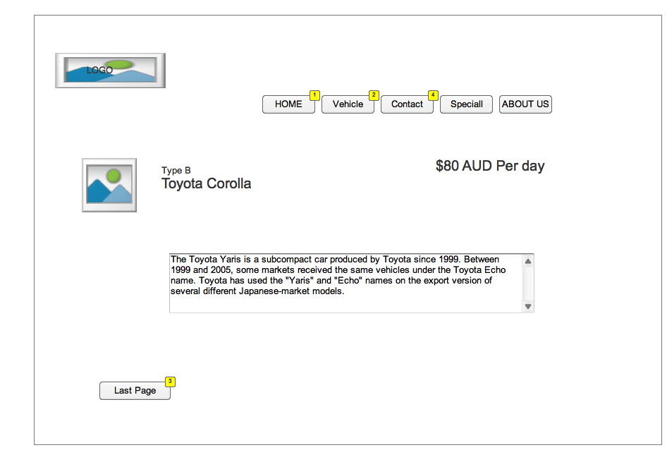

* + 1. Widget Table

| Footnote | Interactions |
| --- | --- |
| 1 | OnClick:  Case 1:  Open Home in Current Window |
| 2 | OnClick:  Case 1:  Open Vehicle in Current Window |
| 3 | OnClick:  Case 1:  Open Vehicle in Current Window |
| 4 | OnClick:  Case 1:  Open Contact in Current Window |

* 1. Type C
     1. User Interface

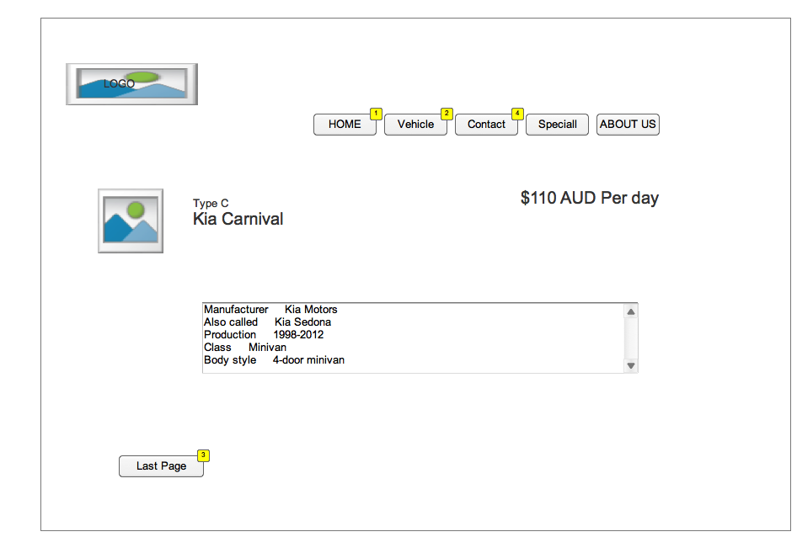

* + 1. Widget Table

| Footnote | Interactions |
| --- | --- |
| 1 | OnClick:  Case 1:  Open Home in Current Window |
| 2 | OnClick:  Case 1:  Open Vehicle in Current Window |
| 3 | OnClick:  Case 1:  Open Vehicle in Current Window |
| 4 | OnClick:  Case 1:  Open Contact in Current Window |

* 1. Type D
     1. User Interface

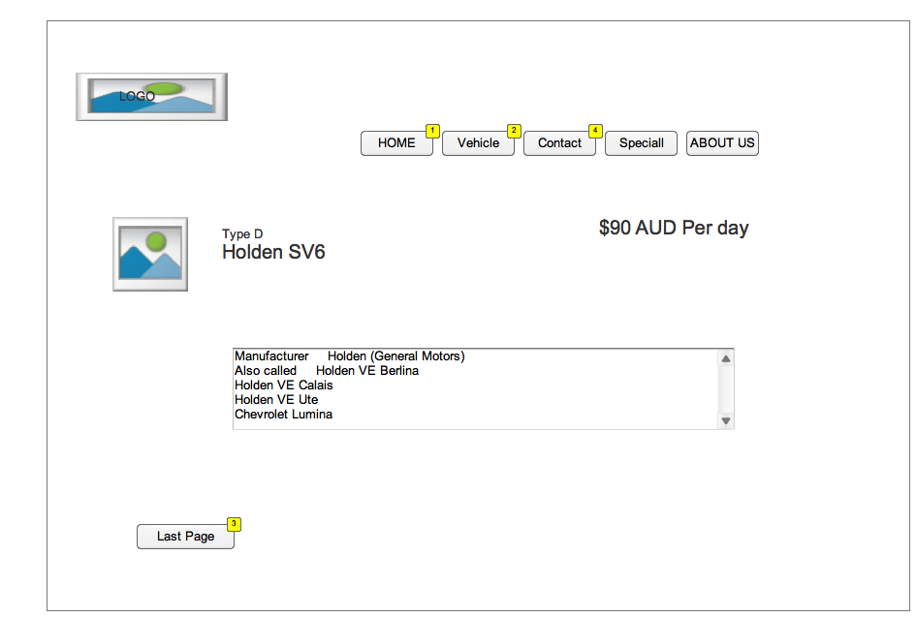

* + 1. Widget Table

| Footnote | Interactions |
| --- | --- |
| 1 | OnClick:  Case 1:  Open Home in Current Window |
| 2 | OnClick:  Case 1:  Open Vehicle in Current Window |
| 3 | OnClick:  Case 1:  Open Vehicle in Current Window |
| 4 | OnClick:  Case 1:  Open Contact in Current Window |

* 1. Contact
     1. User Interface

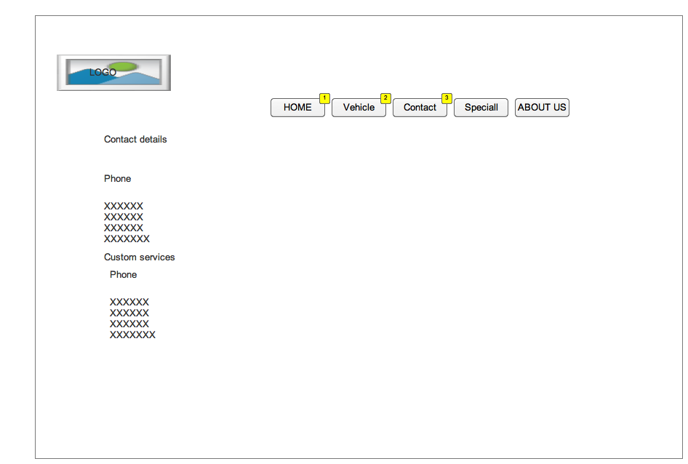

* + 1. Widget Table

| Footnote | Interactions |
| --- | --- |
| 1 | OnClick:  Case 1:  Open Home in Current Window |
| 2 | OnClick:  Case 1:  Open Vehicle in Current Window |
| 3 | OnClick:  Case 1:  Open Contact in Current Window |

1. Masters
   1. Master List

New Master 1  
Folder

* 1. New Master 1